34. Basics of Trigger - 18 May 2022

Definition: A trigger is a piece of code which execute automatically on a particular event for a particular operation.

OR

A trigger is **an Apex script that executes before or after data manipulation language (DML) events occur**. Apex triggers enable you to perform custom actions before or after events to record in Salesforce, such as insertions, updates, or deletions.

Events:

1] before

2] after

Operations:

1] Insert

2] Update

3] Delete

4] Undelete

Context Variables:

1] trigger.new

2] trigger.old

3] trigger.oldMap

4] trigger. newMap

5] trigger.isInsert

6] Trigger.isUpdate

7] trigger.isDelete

8] trigger.isUndelete

9] trigger.isBefore

10] trigger.isAfter

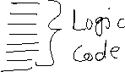

User Story 1: When Account Type is “Prospect”, then Rating should be “Hot”. Else nothing.

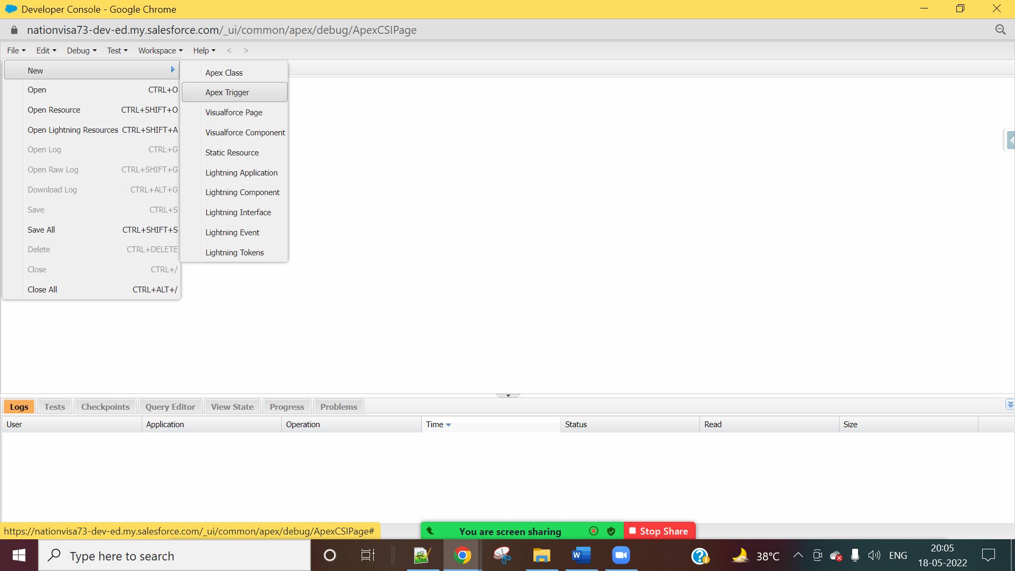

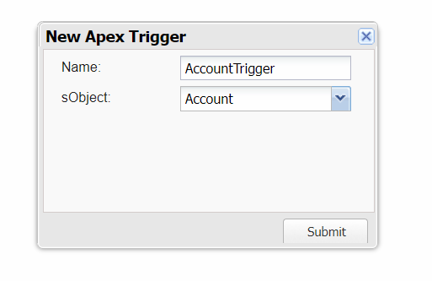



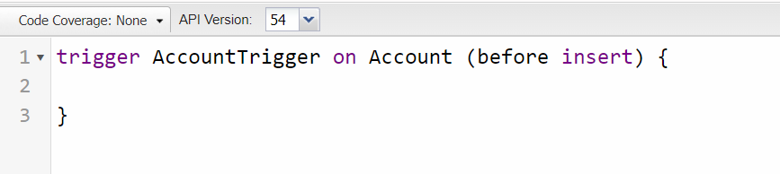

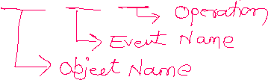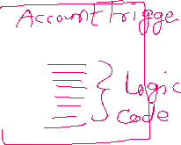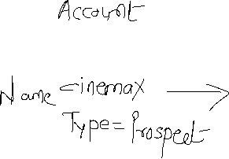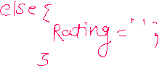

|  |  |
| --- | --- |
| **Event** | Before |
| **Operations** | Insert, Update |
| **Trigger** | Account |
| **Affecting Object** | Account |

trigger AccountTrigger on Account (before insert, before update) {

for(Account objAcc : trigger.new){

if(objAcc.Type == 'Prospect'){

objAcc.Rating = 'Hot';

}

else{

objAcc.Rating = '';

}

}

}

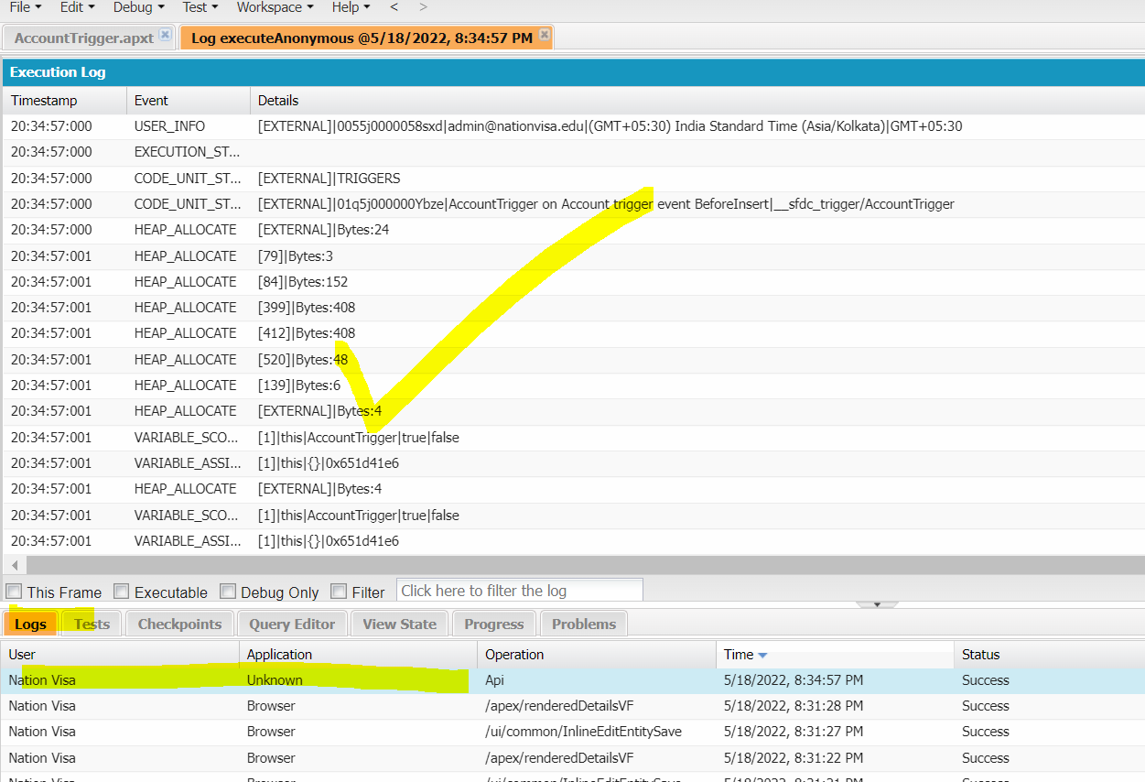



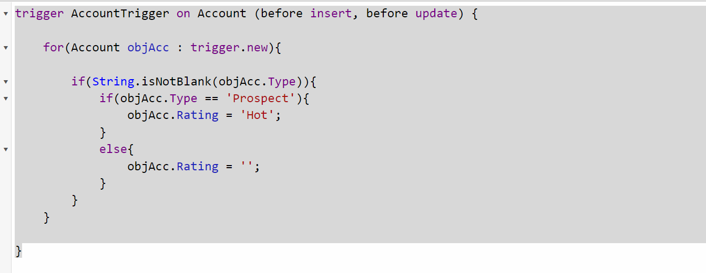



User Story 2] If Applicant Gender is “Male” and DOB month is “August”, then Applicant must be eligible for Police Verification. Else Not.

Show Error, if Email Id is Blank.

|  |  |
| --- | --- |
| **Event** | Before |
| **Operations** | Insert, Update |
| **Trigger** | Applicant__c |
| **Affecting Object** | Applicant__c |

trigger ApplicantTrigger on Applicant__c (before insert, before update) {

for(Applicant__c objApplicant : trigger.new){

if(objApplicant.Gender__c =='Male' && objApplicant.DOB__c.month() ==8){

objApplicant.Police_Verification__c = true;

}

else{

objApplicant.Police_Verification__c = false;

}

if(String.isBlank(objApplicant.Email_Id__c)){

objApplicant.Email_Id__c.addError('Email id can not be blank');

}

}

}

Assignment:

User Story 1] When

- Account SLA = Gold, then Description = ‘Oo lala’.

- SLA = Silver, Then Description =’Yahoo’

- Else Description = Blank

2] If Case status is “New” and Origin is “Phone” → Product should be “GC1020”.

- If Case status is “Working” and Origin is “Web” → Product should be “GC1060”.

If Case status is “Escalated” and Origin is “Email” → Show Error “This case can not be escalated”

3] Prevent Applicant Record if PAN Card is not available.

ORDER OF EXECUTION

https://www.apexhours.com/order-of-execution-salesforce/